

Drop off Full-Sized toiletries now\* – September 15 to Vera Bradley (lower level across from elevator)



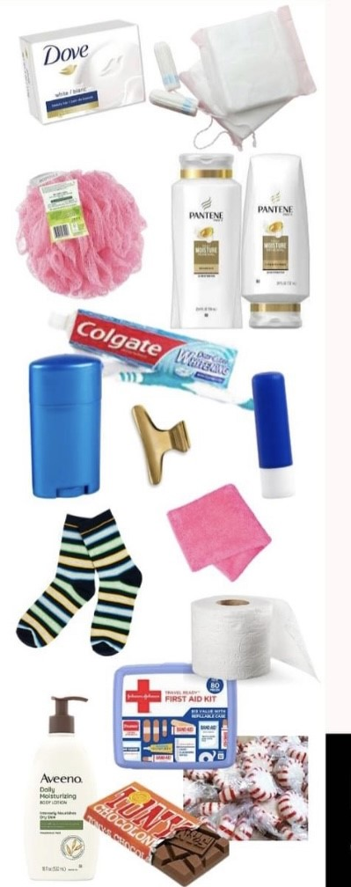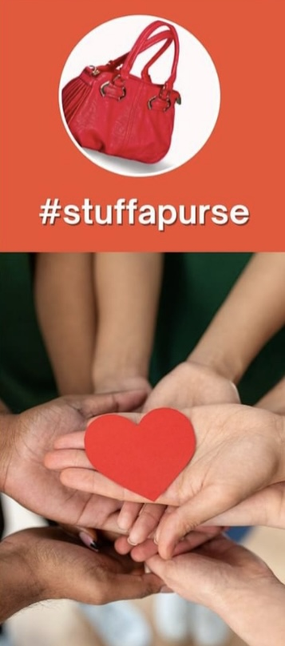

\*enter to win a plush blanket of your choice with your donation!