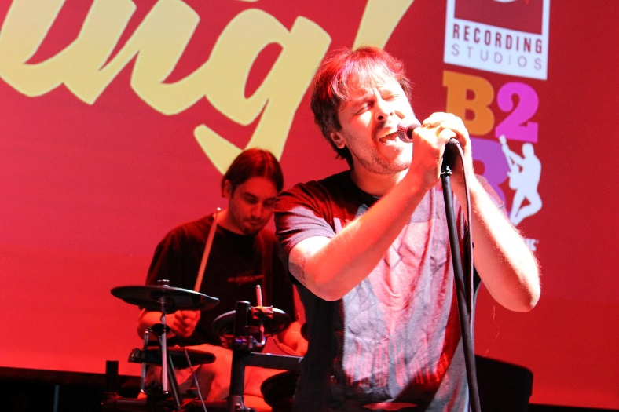 

**FOR IMMEDIATE RELEASE**

August 14, 2017

Contact: Kelly Gilfether

Marketing Director/Manassas Mall

Telephone: 703.368.7232

E-mail: [kellygilfether@pyramidmg.com](mailto:kellygilfether@pyramidmg.com)

##### See Who Can Rock the Mic at The Stand Up & Sing Finals!

**Manassas, VA. –** Watch the top-10 *Stand Up and Sing!* performers compete for their first record deal in the August 15th  finale at Uptown Alley. Come ready to be impressed and cheer on outstanding up and coming local artists! The show starts at 6:00pm, don’t miss out!   
  
The top performer will earn a $1,000 recording package with lead engineer Ken Schubert at Cue Recording Studios; producers of 10 gold and platinum records to date. The second place winner will receive $500 [Bach 2 Rock](https://www.b2rmusic.com/) rehearsal/performance space rental and $150 American Express gift card. Last but not least the third place winner walk away with $150 [Uptown Alley](https://www.manassasmall.com/tenants/uptown-alley/) family fun pack and $100 American Express gift card.

**###**

For updates or information on Manassas Mall and other events, please visit our website at [**www.ManassasMall.com**](http://www.ManassasMall.com), like us on Facebook at[**www.facebook.com/manassasmall**](http://www.facebook.com/manassasmall), and follow us on Twitter at [**www.twitter.com/manassasmal**l](http://www.twitter.com/manassasmall) and Instagram at **www.**[**Instagram.com/manassasmall**](https://instagram.com/manassasmall/) .